Nightingale College
Mission Fulfillment Measures – Fall 2025
Dashboards: College MFM Dashboard - Sigma

Contents
1. Learner Academic Success 2
Cognitive 2
1.1.1 General Education Outcomes 2
1.1.2 Nursing Education Outcomes 3
Practice 4
1.2.1 EL Evaluation and Survey Metrics 4
Everyday Ethical Comportment 5
1.3.1 LSS Code of Conduct Report 5
1.3.2 Wellness Measures 6
2. Serving Diverse Communities 6
2.1 Learner Demographics 6
2.2 Faculty Demographics 9
2.3 Alumni Work Placement Settings 11
2.4 Learner Satisfaction 12
3. Closing Equity Gaps 14
3.1 Persistence to Completion 14
3.2 Retention 15
3.3 Licensure 16
4. Scale and Sustainability 16
4.1 Credit Load 16
5. Comparison Data 18

1. Learner Academic Success

Cognitive

1.1.1 General Education Outcomes
Function | Last Update
General Education | 9.16.25
Benchmark(s) | Statistics
70% in all Competency frames
Sources | Narrative
College MFM Dashboard - Sigma | 2025-3: Successes  General Education outcomes consistently exceed the established benchmark across most competency areas and semesters, with an overall grand average of 78.39%. Competencies such as Human Ideals and Ethics (83.09%), Global Perspectives (81.59%), Written and Verbal Communication (80.83%), and Teamwork and Collaboration (79.88%) demonstrate sustained performance well above the benchmark. These results suggest strong curricular alignment, effective assessment practices, and successful implementation of instructional strategies aimed at holistic learner development.  Areas for Improvement  Quantitative Reasoning remains the most persistent area of concern, with a grand average of 65.83%, falling below the benchmark in most semesters. While modest improvements are evident toward later terms (reaching 70.19% in 2025-3), inconsistent performance suggests a need for targeted curricular scaffolding, enhanced instructional supports, and potential revision of assessment instruments to better align with learning outcomes.
Tactic | Tactic (If Applicable)
 | Implement a thorough process for curriculum, data points, and measurement items
NWCCU Standard | NWCCU Standard Description
Standards - NWCCU  1.C.6 | “Consistent with its mission, the institution establishes and assesses, across all associate and bachelor level programs or within a General Education curriculum, institutional learning outcomes and/or core competencies. Examples of such learning outcomes and competencies include, but are not limited to, effective communication skills, global awareness, cultural sensitivity, scientific and quantitative reasoning, critical analysis and logical thinking, problem solving, and/or information literacy.”

1.1.2 Nursing Education Outcomes
Function | Last Update
Nursing Education | 9/19/2025
Benchmark(s) | Statistics
70% in all 8 competencies | 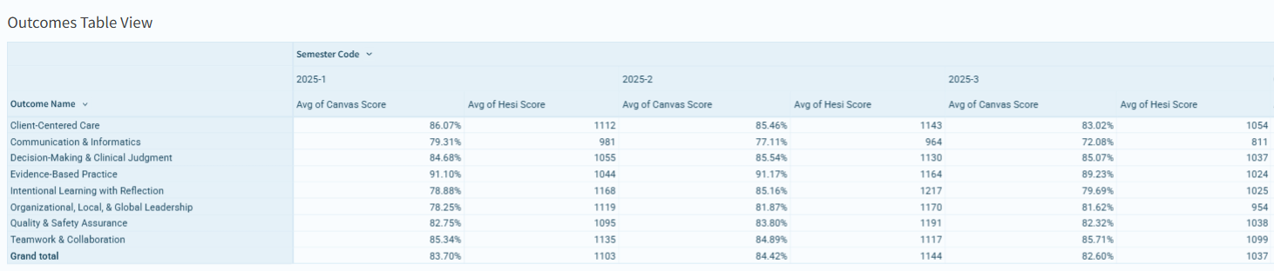
Sources | Narrative
College MFM Dashboard - Sigma | 2025-3: Benchmark: 70% across all eight competency frames- All scores remained above the benchmark of 70% for Fall. There was a slight dip in Communication and Informatics scores, and this has been attributed to an increase in learners' use of AI as misrepresentation on papers, as well as learner reports of combined workload overload.  Successes  BSN outcomes show strong achievement across nearly all competencies, with a grand average Canvas score of 81.12%. Particularly strong performance is observed in Evidence-Based Practice (88.62%), Decision-Making and Clinical Judgment (84.63%), and Teamwork and Collaboration (82.35%). Complementary HESI scores reinforce these findings, suggesting reliable alignment between course-level assessment and standardized measures of student learning.  Areas for Improvement  Communication and Informatics is the lowest-performing competency, with a 74.06% average, hovering just above the benchmark and showing variability across semesters. Additionally, earlier low HESI scores in several competencies point to the need for continued faculty development to ensure consistent instructional delivery, assignment clarity, and reinforcement of communication skills across the curriculum.
Tactic | Tactic (If Applicable)
 | Faculty development is a primary focus to ensure faculty are facilitating the curriculum in the most effective ways possible. Continual curriculum review and enhancements continue to develop positive learner outcomes.
NWCCU Standard | NWCCU Standard Description
Standards - NWCCU 1.C.6 | Consistent with its mission, the institution establishes and assesses, across all associate and bachelor level programs or within a General Education curriculum, institutional learning outcomes and/or core competencies. Examples of such learning outcomes and competencies include, but are not limited to, effective communication skills, global awareness, cultural sensitivity, scientific and quantitative reasoning, critical analysis and logical thinking, problem solving, and/or information literacy.

Practice

1.2.1 EL Evaluation and Survey Metrics
Function | Last Update
Nursing Education | 9/19/2025
Benchmark(s) | Statistics
 | 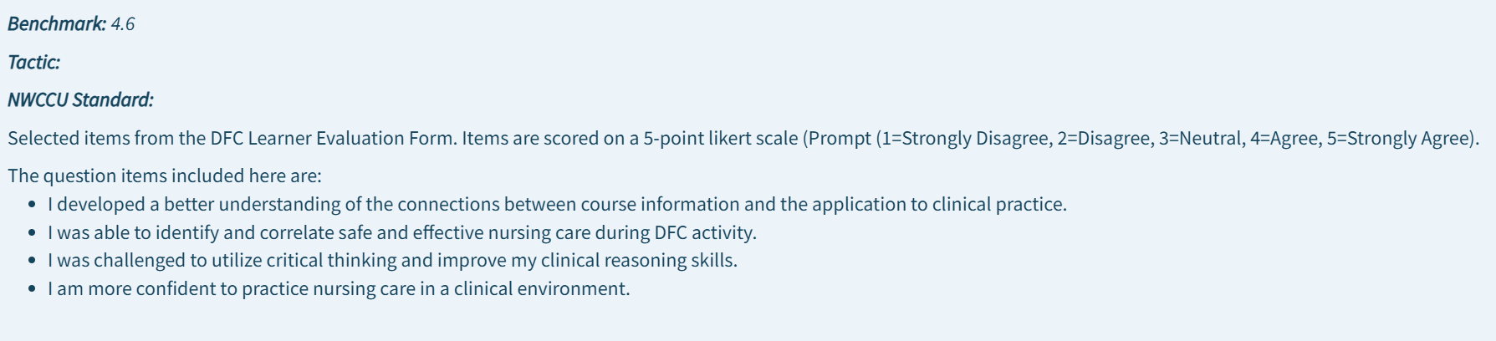
Sources | Narrative
College MFM Dashboard - Sigma | Key Successes  Across all observed semesters, EL evaluation scores consistently meet or exceed the established benchmark, demonstrating sustained learner satisfaction and perceived educational value of experiential learning activities. Mean scores for each item remain tightly clustered between 4.62 and 4.77, indicating both high performance and stability over time.  Strengths by Outcome Area include:  Application to Practice:  Learners consistently report a strong understanding of how course content connects to clinical practice, with scores ranging from 4.62 to 4.72, suggesting effective integration of didactic and experiential components.  Safe and Effective Nursing Care:  The highest scoring item across semesters relates to learners’ ability to identify and correlate safe and effective nursing care during DFC activities (up to 4.77), reinforcing the role of experiential learning in clinical preparedness and patient safety competence.  Critical Thinking and Clinical Reasoning:  Scores consistently meet or exceed benchmark thresholds (4.64–4.73), indicating that experiential activities effectively challenge learners to analyze, evaluate, and apply clinical judgment skills in realistic contexts.  Clinical Confidence:  Learner confidence in practicing nursing care in clinical environments remains strong across semesters, with scores consistently at or above 4.65, supporting the conclusion that experiential learning contributes meaningfully to learner readiness for professional practice.  Collectively, these results provide direct evidence of educational effectiveness, affirming that experiential learning strategies are aligned with course objectives and institutional learning outcomes.  Areas for Reflection and Continuous Improvement  While EL metrics demonstrate high and stable performance, the consistently elevated scores suggest that this metric has transitioned from a performance improvement indicator to a maintenance and sustainability indicator. As such, the primary opportunity for improvement lies not in remediation, but in proactive quality assurance.  Key considerations moving forward include:  Scalability and Consistency:  As institutional enrollment grows, maintaining consistent experiential quality across clinical sites, faculty facilitators, and learner cohorts will be essential. Continued monitoring will ensure that high satisfaction levels are sustained across modalities and geographic regions.  Disaggregated Analysis  Current aggregate results are strong; however, disaggregating EL metrics by program, course level, or learner subgroup may reveal opportunities to further refine experiential design and faculty facilitation strategies.  Integration with Other MFM Indicators:  Aligning EL survey outcomes more explicitly with persistence, retention, and licensure success metrics will strengthen evidence of institutional effectiveness and support closed-loop assessment narratives.  The Experiential Learning Evaluation and Survey Metrics demonstrate consistent, benchmark exceeding performance, confirming the effectiveness of direct faculty facilitated clinical experiences in supporting learner application of knowledge, clinical reasoning, and professional confidence. Rather than indicating a need for corrective action, these results support a focus on sustainability, scalability, and deeper analytic use of learner feedback as part of the institution’s ongoing commitment to continuous improvement and mission fulfillment. -exceeding performance-facilitated clinical experiences in supporting learner application of knowledge, clinical reasoning, and professional confidence. Rather than indicating a need for corrective action, these results support a focus on
Tactic | Tactic (If Applicable)
By the end of Q4 of 2025, the overall learner satisfaction survey score will increase as measured by a specific focus to improve the quality of faculty score to 4.35 or greater.

Review the learner satisfaction surveys to evaluate the qualitative comments that are relevant to perception of faculty and create list of items to address.
NWCCU Standard | NWCCU Standard Description
Standards - NWCCU  1.B.1 | The institution demonstrates a continuous process to assess institutional effectiveness, including student learning and achievement and support services. The institution uses an ongoing and systematic evaluation and planning process to inform and refine its effectiveness, assign resources, and improve student learning and achievement.

Everyday Ethical Comportment

1.3.1 LSS Code of Conduct Report
Function | Last Update
Nursing Education | 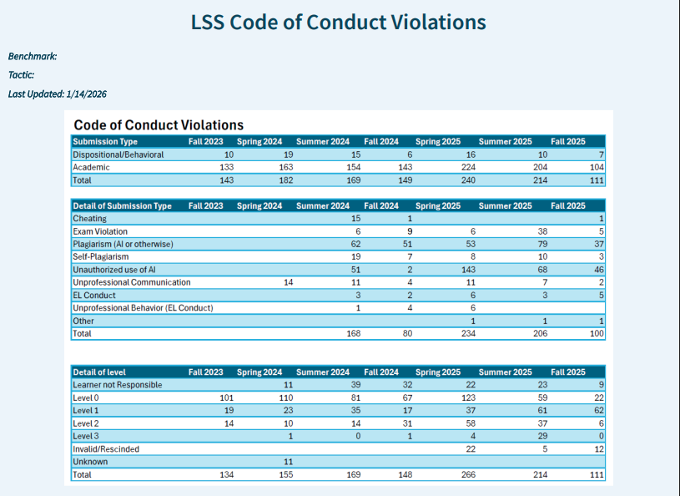
Benchmark(s) | Statistics
Sources | Narrative
College MFM Dashboard - Sigma | 2025-3: Areas for Improvement and Continuous Enhancement  While the current reporting structure demonstrates alignment with institutional values and compliance expectations, opportunities exist to enhance the analytic and improvement value of this metric:  Quantitative Trend Analysis:  The report currently lacks clearly articulated numeric benchmarks or trend summaries. Establishing longitudinal indicators (e.g., frequency by category, resolution timelines, recurrence rates) would improve the metric’s usefulness for institutional effectiveness analysis.  Integration with Learner Success Metrics:  Linking Code of Conduct data with persistence, retention, and learner satisfaction metrics could reveal early indicators of disengagement or external stressors impacting learner behavior. This would strengthen closed-loop assessment and support targeted interventions.  Disaggregated Reporting:  Future enhancements may include disaggregation by program, modality, or learner cohort to ensure equity and consistency in policy application while identifying populations that may benefit from additional support or communication.
Tactic | Tactic (If Applicable)
NWCCU Standard | NWCCU Standard Description
Not Applicable

1.3.2 Wellness Measures
Function | Last Update
General & Nursing Education | This metric is still under development and not currently reportable.
Benchmark(s) | Statistics
Sources | Narrative
Tactic | Tactic (If Applicable)

2. Serving Diverse Communities

2.1 Learner Demographics
Function | Last Update
IAE
Benchmark(s) | Statistics
Sources | Narrative
College MFM Dashboard - Sigma | Metric Purpose: Monitor access, representation, and equity across the learner population  NWCCU Alignment: Standards 2.D.2, 2.G.1  Learner demographic data provide critical context for understanding who the institution serves and how effectively it fulfills its mission to educate diverse learners across geographic, socioeconomic, and life-stage contexts. The demographic indicators reflect an institution intentionally structured to serve adult, working, and non-traditional learners across a wide national footprint.  Key Strengths  Program Growth and Access  Learner population data show sustained growth across programs over multiple years, indicating strong demand for nursing education pathways and effective recruitment strategies. Growth trends demonstrate the institution’s capacity to scale while maintaining access for learners across multiple credential levels.  Geographic and Community Reach  Learners are distributed across metropolitan, micropolitan, rural, and small-town RUCA classifications, underscoring the institution’s reach into underserved and non-urban communities. This geographic diversity aligns directly with the mission to expand access to nursing education beyond traditional campus-based models.  Age and Life-Stage Diversity  Learner age data show strong representation across adult age bands (30–39, 40–49, and 50+), reflecting the institution’s effectiveness in serving career-changing, advancing, and returning learners. This diversity necessitates—and supports—flexible delivery models, learner support systems, and applied learning approaches.  Socioeconomic Representation  Income and dependent data indicate that a significant portion of learners manage family, employment, and financial responsibilities concurrently with enrollment. The presence of learners across income ranges and household sizes reinforces the importance of institutional flexibility, advising, and wraparound support structures.  Racial and Ethnic Diversity  Learner race and ethnicity data show representation across multiple groups, including historically underrepresented populations. While White learners remain a majority, the presence of Black/African American, Hispanic/Latino, Asian, and multiracial learners reflects ongoing progress toward diversifying the nursing workforce.  Areas for Continuous Improvement  Equity Gap Monitoring:  While demographic diversity is evident, continued disaggregated analysis of outcomes (persistence, retention, completion) by learner subgroup will be essential to ensure equitable educational experiences and success across populations.  Data Completeness:  A portion of learners report unspecified demographic information. Improving data capture and communication around the purpose of demographic reporting will strengthen institutional equity analyses and accreditation evidence.  Summary Statement – Learners  Overall, learner demographic data demonstrate that the institution serves a broad, diverse, and non-traditional learner population, consistent with its mission and delivery model. Ongoing attention to equity-minded analysis will ensure that institutional growth translates into equitable learner outcomes.
Tactical Code | Tactic (If Applicable)
NWCCU | NWCCU Standard Description
Standards - NWCCU 1.C.6 | Consistent with its mission and in the context of and in comparison with regional and national peer institutions, the institution establishes and shares widely a set of indicators for student achievement including, but not limited to, persistence, completion, retention, and postgraduation success. Such indicators of student achievement should be disaggregated by race, ethnicity, age, gender, socioeconomic status, first generation college student, and any other institutionally meaningful categories that may help promote student achievement and close barriers to academic excellence and success (equity gaps).

2.2 Faculty Demographics
Function | Last Update
Collaborator Experience
Benchmark(s) | Statistics
Sources | Narrative
College MFM Dashboard - Sigma | Metric Purpose: Ensure workforce diversity, academic capacity, and instructional quality  NWCCU Alignment: Standards 2.D.2, 2.G.1  Overview  Faculty demographic data reflect the instructional resources supporting a rapidly growing learner population. These measures provide insight into institutional capacity, academic credentials, and the diversity of perspectives informing teaching and evaluation.  Key Strengths  Credentialed Faculty Workforce  Faculty qualifications indicate a highly credentialed instructional body, with over 96% holding master’s or doctoral degrees and more than one-third holding doctoral credentials. This academic profile supports rigor, credibility, and alignment with nursing accreditation and professional expectations.  Gender Representation  Faculty gender distribution is predominantly female (85.78%), aligning with national nursing workforce trends. This alignment provides professional authenticity and role-modeling for learners entering the nursing profession.  Age and Experience Diversity  Faculty age distribution is well balanced across early-career, mid-career, and senior professionals, supporting mentorship, instructional continuity, and disciplinary depth. This balance strengthens institutional resilience and succession planning.  National Distribution  Faculty are geographically dispersed across a wide range of U.S. states, supporting the institution’s distributed learning model and its ability to deliver regionally responsive education at scale.  Areas for Continuous Improvement  Racial and Ethnic Representation  While faculty racial diversity includes representation across several groups, White faculty comprise approximately 73% of the workforce. Continued efforts to recruit, retain, and support faculty from historically underrepresented backgrounds would strengthen alignment between faculty demographics and learner diversity.  Equity and Data Use  As with learner data, some demographic fields remain unspecified. Enhancing data completeness and leveraging faculty demographic trends in hiring and professional development strategies will support long-term diversity goals.  Summary Statement – Faculty  Faculty demographic data demonstrate strong academic qualification, national reach, and experiential capacity, all of which support institutional scale and learner success. Continued focus on inclusive recruitment and equity-minded workforce development will further strengthen instructional excellence and mission fulfillment.
Tactic | Tactic (If Applicable)
NWCCU | NWCCU Standard Description
Standards - NWCCU 2.F.3 | Consistent with its mission, programs, and services, the institution employs faculty, staff, and administrators sufficient in role, number, and qualifications to achieve its organizational responsibilities, educational objectives, establish and oversee academic policies, and ensure the integrity and continuity of its academic programs.

2.3 Alumni Work Placement Settings
Function | Last Update
Learner Support Services
Benchmark(s) | Statistics
80% one-year post graduation | 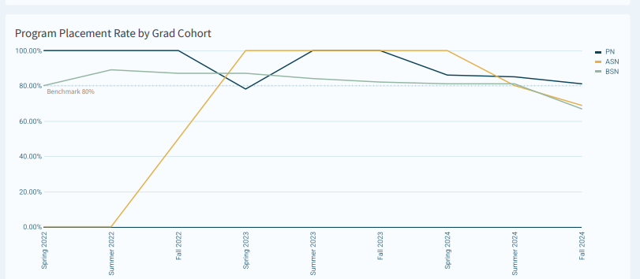
Sources | Narrative
6/12/2025 | Metric Definition: Placement rate is calculated as the number of graduates who have secured employment post-graduation (self-reported or employer-verified) divided by the total number of graduates eligible for placement.  NWCCU Alignment: Standard 2.G.6  Last Reported Update: January 15, 2025 (cohorts at least one year post-graduation)  Overview  Alumni Work Placement Settings provide a direct indicator of institutional effectiveness by measuring the extent to which graduates successfully transition into the workforce. This metric reflects curricular relevance, licensure preparedness, and the institution’s ability to support learners’ professional goals following program completion.  Placement data are disaggregated by program (PN, ASN, BSN) and graduate cohort, allowing for multiyear trend analysis and identification of areas requiring targeted intervention.  Placement data is unavailable for fall 2025, as the MSN program had no graduates during this term.  Key Successes  Consistent Achievement of Benchmark Across Programs  Across nearly all graduate cohorts, placement rates meet or exceed the institutional benchmark of 80%, demonstrating strong alignment between program outcomes and labor market expectations. PN and ASN programs frequently report placement rates at or near 100%, reflecting high employer demand and program relevance within entry level nursing pathways. -level nursing pathways.  Sustained BSN Placement Performance  BSN placement rates remain consistently above benchmark across cohorts from Spring 2022 through Summer 2024, generally ranging from 81% to 89% one year post-graduation. This sustained performance indicates that BSN graduates are well prepared for employment and that the program effectively supports workforce readiness despite increasing cohort sizes.  Improved Data Quality and Transparency  The institution has enhanced placement tracking through licensure data cleaning and reconfiguration, improving the ability to accurately identify graduates in need of additional placement assistance or verification. Breaking placement status into stages provides clearer insight into where graduates are in the employment pipeline and strengthens institutional decision making. -making.  Alignment with Licensure Success  Strong placement rates correspond with high NCLEX licensure pass rates across programs, suggesting a coherent progression from academic preparation to licensure and employment. Together, these indicators reinforce the conclusion that graduates are competitively positioned for entry into professional nursing practice.  Areas for Continuous Improvement  Variability Across Cohorts and Programs  While overall performance meets benchmark expectations, some variability is evident, particularly in smaller cohorts where placement rates fluctuate more dramatically (e.g., lower ASN placement in Fall 2022). These variations are influenced in part by small sample sizes and highlight the importance of contextual interpretation when reviewing cohort level data. -level data.  Verification and Follow-Up  Because placement calculations include both verified and unverified employment, continued emphasis on employer verification and alumni follow-up will further strengthen the reliability and credibility of placement reporting. Improved verification rates may also help identify graduates who would benefit from additional career support services.  Deeper Integration with Learner Support Services  Opportunities exist to more intentionally integrate placement data with learner support, advising, and alumni engagement efforts. Early identification of graduates who have not secured employment within expected timeframes would allow for targeted outreach, resume support, and employer connection strategies.  Alumni Work Placement outcomes demonstrate that the institution is effectively preparing graduates for successful entry into the nursing workforce, with placement rates consistently meeting or exceeding the 80% benchmark across programs and cohorts. Ongoing improvements in data quality, licensure alignment, and placement tracking reflect a mature approach to institutional effectiveness. Continued refinement of analytics and targeted postgraduation support will further strengthen this metric as evidence of mission fulfillment and labor market responsiveness. -graduation support will further strengthen this metric as evidence of mission fulfillment and labor-market responsiveness.
Tactic | Tactic (If Applicable)
Create and execute a plan to expand connections from career services to employers, focusing on areas and sites that are not currently utilized by other functions.

Implement a tracking and reporting system to monitor employment outcomes of graduates one year after completion…to include follow-up surveys, data analytics for trends, and a reporting mechanism to refine the “cradle-to-career” strategy and maintain progress toward the 80% placement goal.

NWCCU | NWCCU Standard Description

2.4 Learner Satisfaction
Function | Last Update
Benchmark(s) | Statistics
4.0 as reflective of Agree on the Likert Scale | 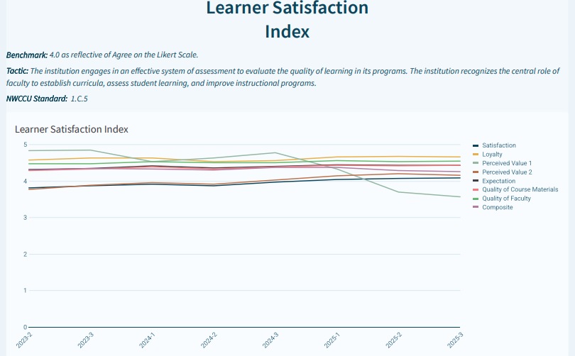
Sources | Narrative
College MFM Dashboard - Sigma | Successes  The composite Learner Satisfaction Index consistently exceeds the benchmark, with recent semesters ranging from 4.26 to 4.37. Strong ratings for Quality of Faculty and Expectation Alignment underscore the institution’s instructional effectiveness and learner-centered focus.  Areas for Improvement  Declines in Perceived Value 1 beginning in 2025 (dropping below 4.0) suggest learner sensitivity to cost, workload, or return-on-investment perceptions. These findings indicate an opportunity to improve communication around program value, career outcomes, and institutional support services.
Tactic | Tactic (If Applicable)
By the end of Q4 of 2025, the overall learner satisfaction survey score will increase as measured by a specific focus to improve the quality of faculty score to 4.35 or greater.

Review the learner satisfaction surveys to evaluate the qualitative comments that are relevant to perception of faculty and create list of items to address.
NWCCU | NWCCU Standard Description
Standards - NWCCU 1.C.5 | The institution engages in an effective system of assessment to evaluate the quality of learning in its programs. The institution recognizes the central role of faculty to establish curricula, assess student learning, and improve instructional programs.

3. Closing Equity Gaps

3.1 Persistence to Completion
Function | Last Update
Institutional Analytics and Effectiveness
Benchmark(s) | Statistics
70%  MSN-TBD | 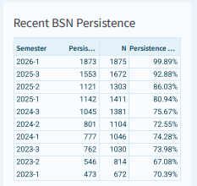
Sources | Narrative
Benchmarks: 70% for ADN and BSN
Successes
Recent BSN cohorts demonstrate strong upward trends, with persistence rates increasing from approximately 73–75% in 2024 to over 92% by 2025-3, culminating in 99.89% for 2026-1. These gains suggest effective retention strategies and learner support interventions.
Areas for Improvement
Earlier cohorts and some programs still fall below benchmark thresholds, indicating uneven persistence outcomes across time and modality. Continued disaggregation by demographic variables will help identify equity gaps and inform targeted support initiatives.

Tactic | Tactic (If Applicable)
 | Collaborate with Faculty Development to determine training needs that could be implemented to address learner feedback from surveys by Q3 2025.
NWCCU Standard | NWCCU Standard
Standards - NWCCU 1.D.2 | Consistent with its mission and in the context of and in comparison, with regional and national peer institutions, the institution establishes and shares widely a set of indicators for student achievement including, but not limited to, persistence, completion, retention, and postgraduation success. Such indicators of student achievement should be disaggregated by race, ethnicity, age, gender, socioeconomic status, first generation college student, and any other institutionally meaningful categories that may help promote student achievement and close barriers to academic excellence and success (equity gaps).

3.2 Retention
Function | Last Update
Institutional Analytics and Effectiveness
Benchmark(s) | Statistics
80% | 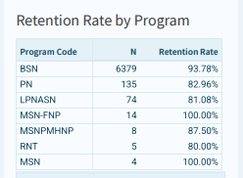
Sources | Narrative
College MFM Dashboard - Sigma | Successes  Most programs exceed the retention benchmark, with BSN retention at 93.78% and graduate programs at or near 100%. These results reflect strong academic advising, instructional continuity, and learner engagement.  Areas for Improvement  Smaller programs and select undergraduate pathways show occasional volatility, likely due to small sample sizes. Monitoring these areas remains important to ensure consistent learner experiences across all programs.
Tactic | Tactic (If Applicable)
 | Develop and implement a continuous monitoring and evaluation framework to track the effectiveness of the specialized services. The framework will include key performance indicators (KPIs) related to learner satisfaction, academic performance, and retention.
NWCCU Standard | NWCCU Standard Description
1.D.2 | Consistent with its mission and in the context of and in comparison with regional and national peer institutions, the institution establishes and shares widely a set of indicators for student achievement including, but not limited to, persistence, completion, retention, and postgraduation success. Such indicators of student achievement should be disaggregated by race, ethnicity, age, gender, socioeconomic status, first generation college student, and any other institutionally meaningful categories that may help promote student achievement and close barriers to academic excellence and success (equity gaps).

3.3 Licensure
Function | Last Update
Institutional Analytics and Effectiveness
Benchmark(s) | Statistics
3-year overall pass rate – 80%  *Program Pass Rates – Aligns with programmatic accreditation standards | 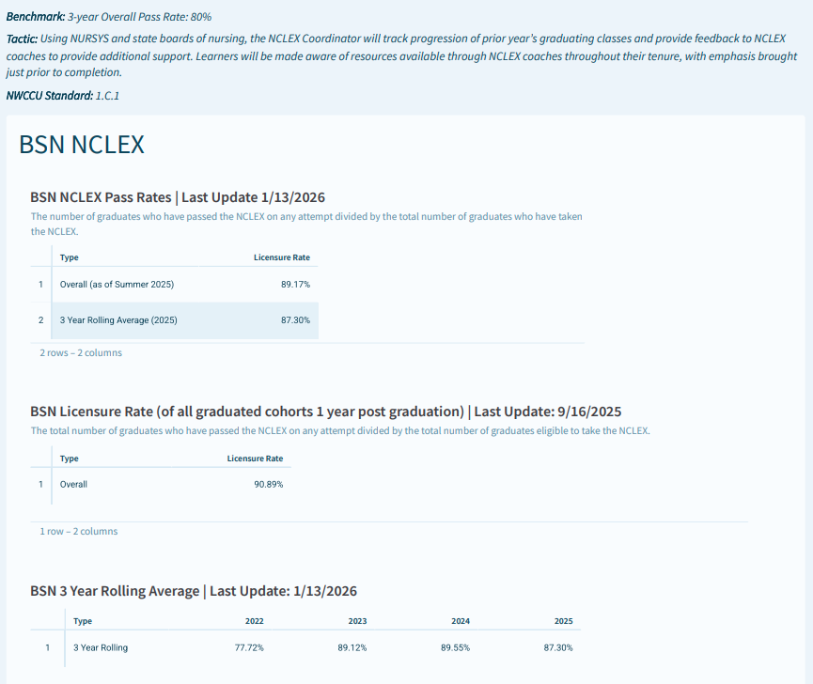
Sources | Narrative
College MFM Dashboard - Sigma | Successes  All licensure programs exceed benchmark expectations. BSN 3-year rolling averages remain above 87%, while PN and ASN programs consistently post pass rates exceeding 85%, often above 90%. These outcomes demonstrate effective preparation and strong alignment between curriculum and licensure standards.  Areas for Improvement  The slight downward trend in PN pass rates in 2025 (86.30%) suggests monitoring is warranted to ensure sustained success as cohorts grow and testing standards evolve.
Tactic | Tactic (If Applicable)
 | Implement solution for NCLEX tracking and reporting.
NWCCU Standard
1.D.2 | Consistent with its mission and in the context of and in comparison, with regional and national peer institutions, the institution establishes and shares widely a set of indicators for student achievement including, but not limited to, persistence, completion, retention, and postgraduation success. Such indicators of student achievement should be disaggregated by race, ethnicity, age, gender, socioeconomic status, first generation college student, and any other institutionally meaningful categories that may help promote student achievement and close barriers to academic excellence and success (equity gaps).

4. Scale and Sustainability

4.1 Credit Load
Function | Last Updated
Institutional Analytics and Effectiveness
Benchmark(s) | Statistics
Average Credit Load:  BSN-11.91  LPNASN – 11  MSNEd – 10  MSNFNP – 8.77  MSNPMHNP- 9.13  PN – 11.28  RNBSN-8 | 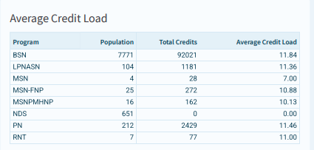
Sources | Narrative
Successes
Average credit loads align closely with established benchmarks for BSN (11.84 vs. 11.85) and PN programs, indicating sound course sequencing and manageable learner workload.
Areas for Improvement
Graduate programs exceed recommended credit loads, particularly MSN-FNP and MSNPMHNP tracks. Ongoing evaluation is needed to ensure workload remains rigorous yet sustainable and does not negatively impact retention or learner satisfaction.

Tactic | Tactic (If applicable)
 | Initiate a semesterly meeting with FMs, SMs, ADON, DON to determine staffing needs, assignments, hiring, and plans to adequately staff nursing courses for subsequent semester by Q1 2025.
NWCCU Standard | NWCCU Standard Description

5. Comparison Data

Function | Last Updated
Accreditation
Benchmark(s) | Statistics Link –
Sources | Narrative
Detailed Peer Comparison Data_MFM_Fall 25.xlsx | Data is updated annually: The College benchmarks its performance against nine (9) peer institutions using meaningful datasets collected from institutional websites and the National Center for Education Statistics (NCES). Peer institutions that share common programs, delivery models, degrees, learner population, and published metrics have been carefully selected. Although a comparison group is identified within the IPEDS Data Feedback Report, the College has identified alternate peer institutions that are smaller in terms of learner population, have nursing as a primary program focus, offer distance education, and provide more current outcome metrics on their website. Comparable data supports Nightingale College’s student achievement measures including metrics for enrollment, retention, placement, pass rates, degrees, programs, and delivery modalities. Disaggregated data includes age, ethnicity, and gender. Data is collected from institutional websites and the College Navigator. College Navigator - National Center for Education Statistics The College is trending slightly lower than peer institutions in this metric. While the College strives to increase opportunities for prospective learners, it is also committed to the responsibility of preparing and progressing learners successfully toward program completion. As a result of continuous assessment, Nightingale College has intensified its efforts to meet the diverse needs of its students by devoting energy and resources to wrap-around services, ensuring that all students, regardless of their background, feel valued and supported.  The College demonstrates strong placement outcomes across its nursing programs, as illustrated in the bar graph below. Due to the increasing graduate population of the BSN program across multiple states, Career Services is in the final stage of contracting with a third-party vendor – potentially Equifax - to implement a more efficient and expedited process for verifying graduate employment outcomes.  The College has a majority-minority student body, with over 70% of learners identifying as non-White or unknown. The distribution is significantly unique in comparison with peer institutions and aligns with the College’s mission.
Tactic | Tactic (If Applicable)
Continue to identify peer institutions that share common programs, delivery models, degrees, learner population, and published metrics to develop a stronger comparison group for benchmarking.
Continue to develop the data-sharing/peer comparison consortium initiative to share data (Q1), and create a dashboard (Q2), and utilize data to enhance institutional effectiveness.
NWCCU Standard | NWCCU Standard Description
Standards - NWCCU 1.D.2 | Consistent with its mission and in the context of and in comparison with regional and national peer institutions, the institution establishes and shares widely a set of indicators for student achievement including, but not limited to, persistence, completion, retention, and postgraduation success. Such indicators of student achievement should be disaggregated by race, ethnicity, age, gender, socioeconomic status, first generation college student, and any other institutionally meaningful categories that may help promote student achievement and close barriers to academic excellence and success (equity gaps).

